**iOS Developer Long Question**

Please write an iOS app within **1.5 hours**. The UI should looks like the screen below. Data of the list will be provided in JSON format attached below. You can hardcode the JSON string in your app. Please parse the JSON and display the corresponding data.

You may use any Pod libraries.

**[How to Submit]**  
Please create a new Xcode workspace/project and implement your logic, the code should be able to build and run on the Simulator.  
When you finished, please ZIP your entire Xcode workspace/project and send back to us.

JSON string attached below:



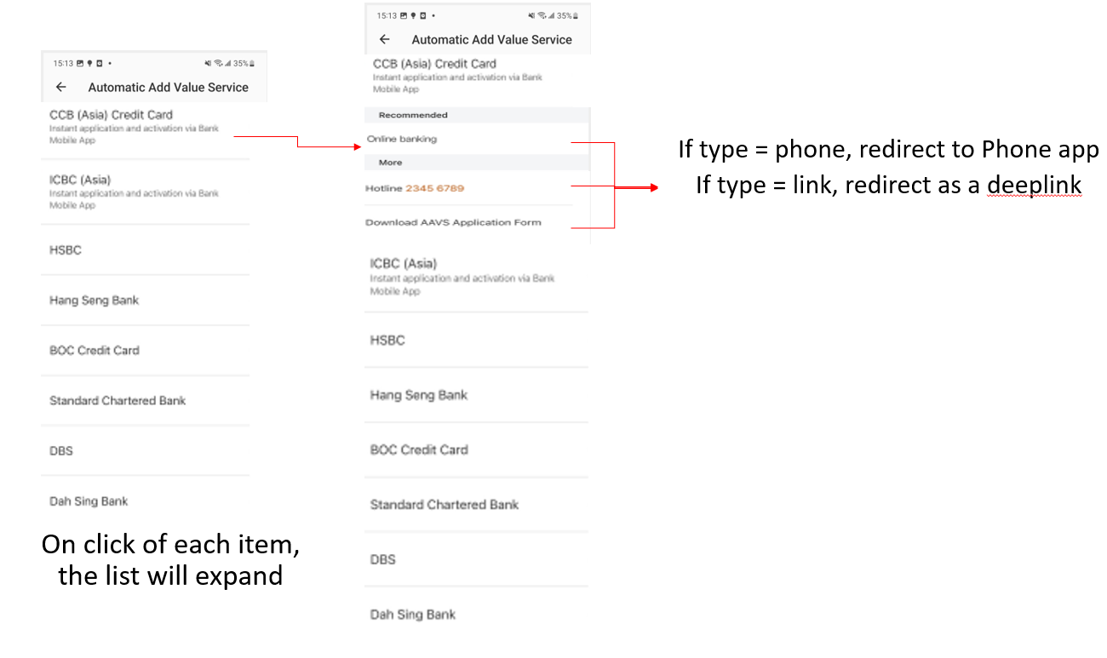

A clearer screenshot is also attached on next page.

